**LAB 10**

**Q1. Clear the console windows, then dump the register and flags ,then delay the program for 2seconds.**

**Program:**

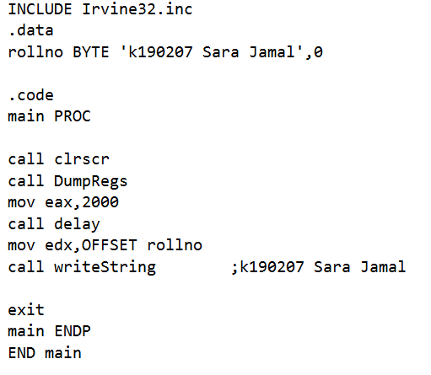

**Output:**

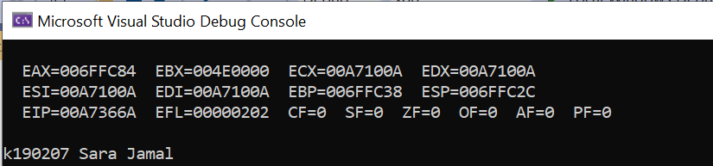

**Q2. Display a null terminated string to the console window, then move the cursor to the next line.**

**Program:**

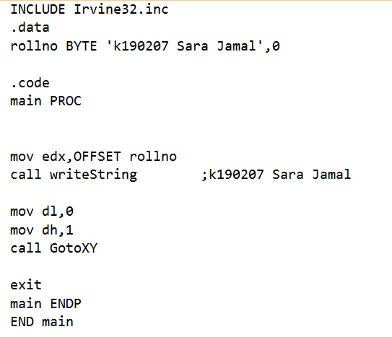

**Output:**

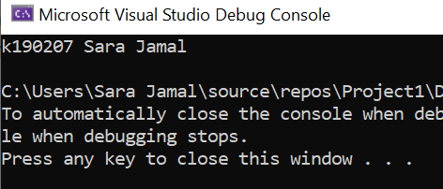

**Q3. Display a null terminated string , which has a newline character embedded in it, to the console window.**

**Program:**

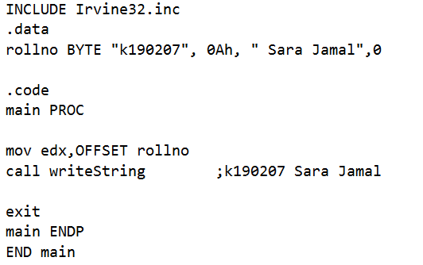

**Output:**

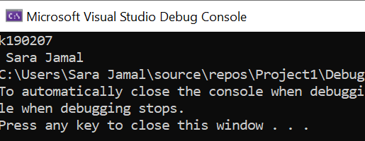

**Q4. Display an unsigned integer in binary representation, then decimal representation, then hexadecimal representation, each on its own line.**

**Program:**

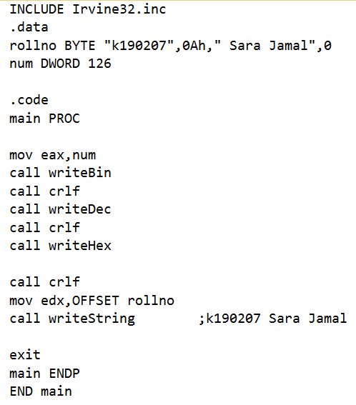

**Output:**

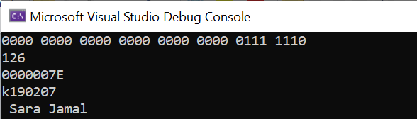

**Q5. Input a string from user**

**Program:**

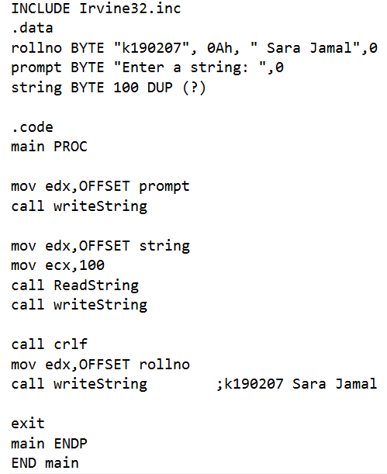

**Output:**

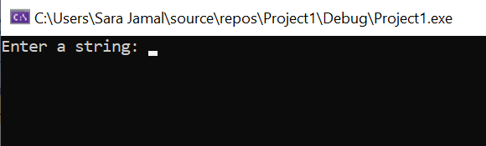

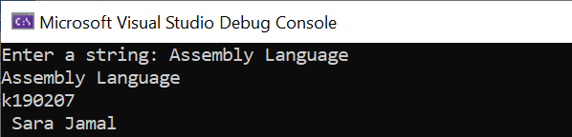

**Q6. Generate and display a random number in the range 1-100. The loop behavior 20 times.**

**Program:**

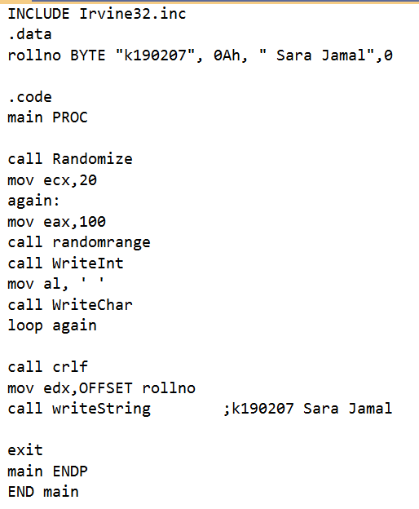

**Output:**

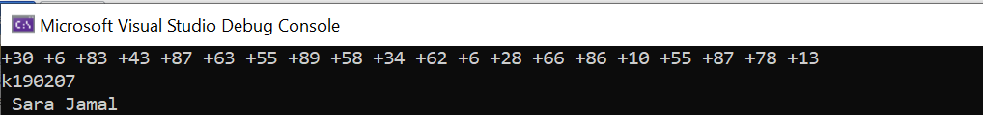

**Q7. Display a null-terminated string with yellow characters on a blue background.**

**Program:**

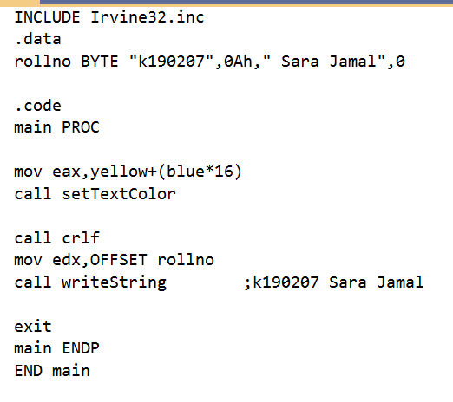

**Output:**

